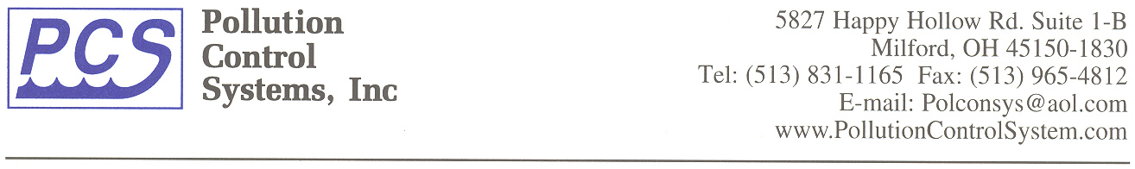

EQUIPMENT PACKAGE
SPECIFICATIONS
FOR CONCRETE PUMP STATION / LIFT STATION

Pollution Control Systems, Inc. (PCS) is pleased to provide the following equipment specifications for your consideration:

Pumps, piping, and controls are to be constructed in accordance with the plans and specifications stated herein. The Contractor will be responsible for supplying the concrete lift station basin. In addition, the Contractor will be responsible for installing the pumps and equipment to complete the system. The pump station equipment package will be a Model _______________.

A. General Specifications

Concrete Pump Station Diameter: _____ feet

Concrete Pump Station Height: _____ feet

B. Access Door (Optional)

A double door access system will be provided for installation in the top of the concrete cover on the influent lift station. The unit shall be of all aluminum construction at a minimum of ¼” thick. All hardware on the unit will be stainless steel and include the necessary concrete anchors. The doors will have an auto lock feature when fully open and include a release handle. The double door unit shall be a Model ______or equal and allow enough open space to remove the pumps.

C. Pumps – Lift Station Equipment Package Can be Provided with Pump Options as Shown

Submersible Pumps (Option #1)

A duplex set of submersible pumps will be provided. Each pump will be of the solids handling type capable of passing 2” solids. The pumps will have a capacity of ___ gpm @ ___ feet TDH. The pump motors will be ___ hp, rated for ___ volts, ___ phase, and ___ cycle. The pumps will be supplied with lift out chains

Grinder Pumps (Option #2)

A duplex set of submersible grinder pumps will be provided. The pumps will be designed to reduce sewage to a finely ground slurry. The pump will have a capacity of ___ gpm @ ___ feet Total Dynamic Head (TDH). The pump motors will be ___ hp, rated for ___ volts, ___ phase, and ___ cycle. Pumps will be supplied with lift out chains.

D. Lift Out Rail System

A guide rail system will be provided for each pump. The system will consist of a cast base unit, a pump adapter assembly, upper guide rail bracket and galvanized guide rails. On deeper units, an intermediate support is necessary to stabilize the rail system.

E. Lifting Hoist (Optional)

A lifting hoist will be supplied to ease pump removal from the basin. The hoist will be a Model ________ manufactured by _________ or approved equal. The hoist assembly will include an embedded socket for hoist placement in the top of the concrete cover.

F. Piping

The station discharge piping will be schedule 40 steel and will terminate with a 125 # flanged tee. Each pump discharge line will have a check valve and a gate valve. The discharge pipe will end at the top 90-degree elbow. All wall penetrations or wall sleeves for discharge piping are to be supplied by the installing contractor.

G. Central Control Panel

A central control system installed within a weatherproof enclosure will be provided. The fiberglass enclosure will be rated a NEMA 4X and mounted on or near the top of the station lid. The panel will contain a magnetic starter or contactor and an H-O-A selector switch for each pump. It will alternate the pumps on successive cycles and turn on the second pump if the first one fails or if the inflow exceeds the capacity of one pump. Properly sized circuit breakers or fuses will protect all pumps and controls. All pump and level control wiring will pass through the top of the wet well and into the bottom of the control panel.

H. Junction Box (Optional)

When the control panel is remotely located from the station, a weatherproof junction box will be provided on top of the station to accept the equipment control cables.

I. Level Controls

Three (3) float switches will be suspended from a bracket mounted inside the station. These float switches will be suspended at proper depths to control the “OFF”, “ON”, and “Both Pumps ON” levels.

(Optional) A fourth float switch for “Emergency High Water Alarm” can be provided. A red flashing warning light will be mounted in the control panel to indicate a high water condition.

J. Guarantee

PCS will guarantee for one (1) year from the scheduled ship date that the vessel and all component equipment will be free from defective materials and workmanship. PCS will furnish replacement parts for any component considered in the opinion of PCS to be defective, whether of his or other manufacturer during the guarantee period.

